Technical Documentation
Custom Trade Data Automation & Analysis

Date: 02-07-2026
Version: v1
Author: Siranj

Table of Contents
1. Introduction 4
1.1 Purpose 4
1.2 Scope 4
1.3 Audience 5
2. System Overview 5
2.1 Architecture 5
2.2 Technologies Used 7
2.3 Dependencies 7
3. Installation Guide 8
3.1 Source Code Repository 8
3.2 Prerequisites 8
3.3 System Requirements 9
3.4 Installation Steps 9
3.4.1 Master Folder Setup (GitHub, Local Execution, Installation) 9
3.4.2 Nodejs installation 10
3.4.3 n8n Installation 10
3.4.4 KNIME Analytics Platform 12
3.4.5 DB Browser (SQLite) 14
3.4.6 Power BI Desktop 14
3.4.7 Git GUI 15
4. Configuration Guide 16
4.1 Configuration Parameters 16
4.1.1 Adding workflows to n8n 16
4.1.2 Configuring API Key for n8n 17
4.1.3 Configuring API Key for KNIME (.env file) 18
4.2 GitHub Setup 19
4.2.1 Pulling files only. 19
4.2.2 Connecting GitHub account 20
4.3 Environment Setup 21
4.3 External Services Integration 21
5. Usage Guide 22
5.1 User Interface Overview 22
5.2 User Authentication 23
5.3 Core Functionality 23
5.4 Advanced Features 24
5.5 Troubleshooting 26
5.5.1 Using log files (Recommended) 26
5.5.2 Using n8n execution log 27
6. API Documentation 29
6.1 Endpoints 29
6.2 Request and Response Formats 30
7. Database Schema 30
7.1 Entity-Relationship Diagram 30
7.2 Table Definitions 30
7.3 Relationships and Constraints 31
8. Testing 31
8.1 Test Plan 31
8.2 Test Cases 31
8.3 Test Results 34
9. Support and Maintenance 35
9.1 Troubleshooting Guide 35
9.2 Frequently Asked Questions (FAQs) 35
9.3 Known Issues and Limitations 35
9.4 Contact Information 35
10. Future Aspects 35
11. Change Log 36
11.1 Version History 36
11.2 Change Summary 36
12. Glossary 36
12.1 References 36

1. Introduction

1.1 Purpose
[Define the goal and objectives of this document. Describe what system, application, or project this documentation covers.]
The primary objective of this document is to detail the architecture, implementation, and operational workflows of the Automated Trade Data Analysis Pipeline. This system was engineered to transform raw, fragmented trade data into structured, actionable business intelligence.
The core objectives of the project covered in this documentation include:
- Data Ingestion & Cleaning: Standardizing raw inputs and eliminating anomalies automatically.
- AI-Driven Classification: Leveraging artificial intelligence to categorize trade records dynamically.
- Centralized Storage: Managing processed data securely within a relational database architecture.
- Executive Visualization: Delivering interactive, high-fidelity dashboards to support strategic management decisions.

1.2 Scope
[Detail the boundaries of the system. Specify what is covered in this document and, importantly, what is explicitly out of scope.]
This documentation covers the end-to-end boundaries of the data automation lifecycle.
In-Scope Elements
- Detailed installation and environment configuration guidelines for all integrated software.
- The complete data flow logic, moving from local file systems through automated staging environments.
- Advanced data cleaning protocols and AI classification prompt/logic layers.
- Relational data management configurations using SQLite (and its operational cloud integration structures).
- User interface layouts and dynamic reporting configurations inside Power BI and frontend custom web frameworks.
Out-of-Scope Elements
- Upstream modifications to raw source data generation systems.
- Deep structural modifications to corporate hardware firewalls or underlying network architectures.
- Manual, ad-hoc spreadsheet manipulation outside of the automated workflow logic.

1.3 Audience
This project involves low-code platforms, which will make it easier to understand for non-technical targets and stakeholders. However, to navigate or troubleshoot the pipeline smoothly, having a basic comfort level with the following concepts is helpful:
- Data Basics: Understanding simple rows, columns, and standard text data formats (like JSON files).
- System Operations: Knowing your way around local folders, simple software installations, and visual automation tools.
- Code & Connections: A foundational grasp of how systems talk to each other (APIs) and simple scripting (like Python) for quick troubleshooting.
- Business Intelligence: Knowing how to click, filter, and read charts inside tools like Power BI.

2. System Overview

2.1 Architecture Diagram
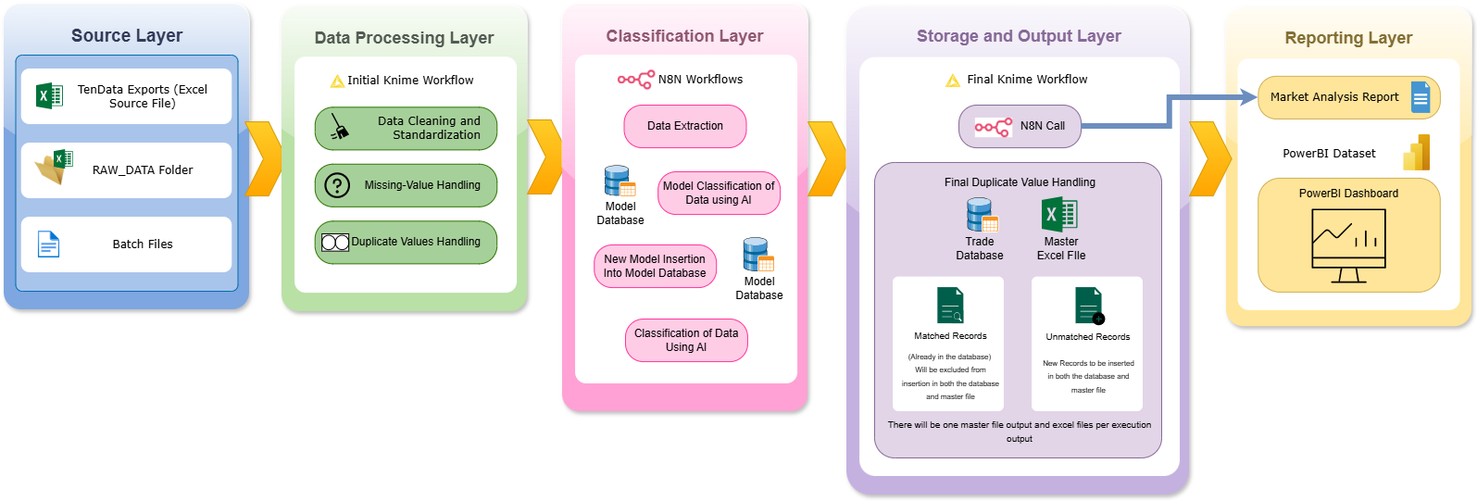

2.2 Data Flow Diagram
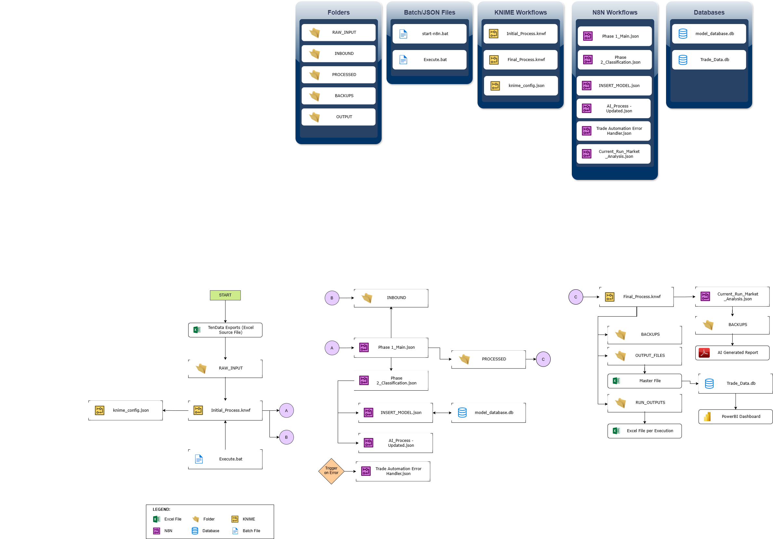

2.3 Technologies Used
[List the core programming languages, frameworks, libraries, operating systems, and tools utilized in the project.]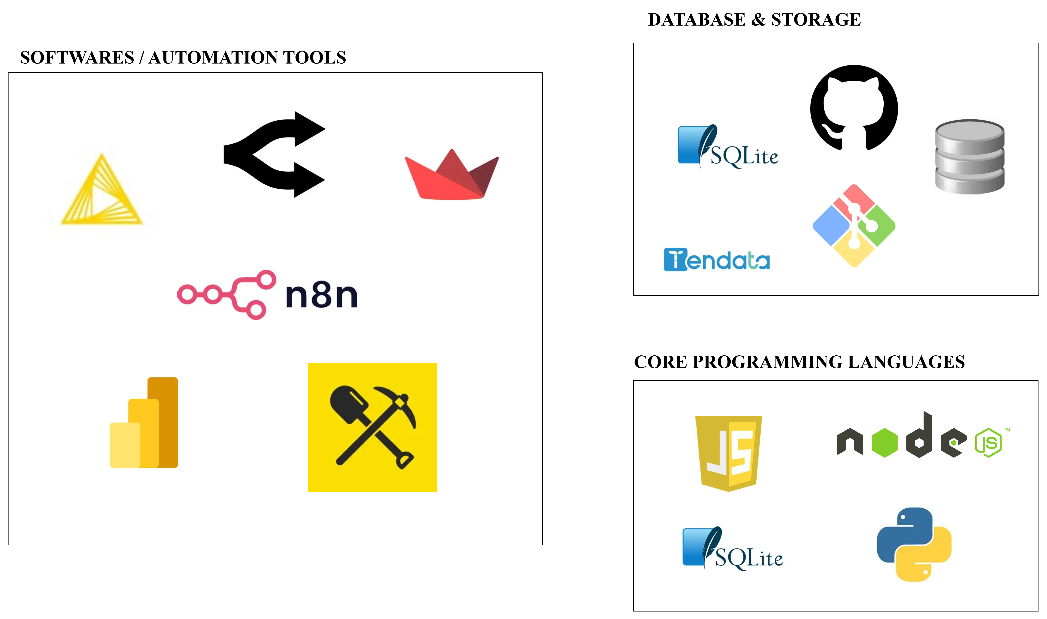

Programming & Scripting Languages | JSON, Python, JavaScript, SQLite, .bat (Windows Batch)
Frameworks/Process | ETL (Extract, Transform, Load), n8n, LLM Caching
Software/Tools | KNIME Analytics Platform  n8n Workflow Automation  DB Browser (SQLite)  PowerBI Desktop  Git UI
Libraries | Pandas, Streamlit
Data Sources | Tendata, tradedatapro

2.4 Dependencies
[List any external dependencies, third-party services, APIs, or internal company modules required for the system to function.]
Category | Name | Purpose
External API Keys | Open Router API key | Powering the AI-driven trade record classification
Custom n8n Nodes | n8n-nodes-sqlite, n8n-nodes-splitinbatches-advanced | Allows n8n to connect to local databases and process massive batches
Knime Extensions | Node Pit | Enables automated background execution via command line
Python Libraries | pandas, streamlit | Handles high-speed data frame manipulation and visual layout rendering
Raw Data Extraction | Tendata, tradedatapro | Provides external raw source datasets for trade analysis ingestion

3. Installation Guide

3.1 Source Code Repository
The project is maintained through GitHub repository ‘trade-data-automation’. Since it is a public repository, anyone can access it. Make sure not to push any company restricted data.
[repository-> siranjks/trade-data-automation]
Daphnie’s Fork
[repository-> 0nlyException/trade-data-automation]

Inside the repository, you will find source codes for all the nodes for n8n and knime, workflow files, testing phase files, documentations/instructions, cmd logs and streamlit files.
You will not find any raw data or installation files there.

3.2 Prerequisites
Name | Extensions (if any) | Minimum Version | Type
Operating System | - | Windows 10 or above | Host Platform
KNIME Analytics Platform | NodePit Batch  NodePit Runner for Knime | 5.11.0 | Software
Node.js | - | v24.15.0 (LTS)(April152026) | JavaScript Runtime Environment (for n8n)
n8n | Community nodes:  1)n8n-nodes-sqlite  2) n8n-nodes-splitinbatches-advanced | Community Edition v2.20.11 | Self-hosted Automation Tool (Web Interface)
DB Browser (SQLite) | - | V3.13.1 | Software/Tool
Power BI Desktop | - | Latest stable | Software
streamlit | Python | Latest | Python Web Framework
GitHub | - | - | Software/Cloud
[List software, hardware, network permissions, or access rights required before beginning the installation process.]

3.3 System Requirements
[Specify hardware requirements (CPU, RAM, Storage) and supported operating systems/versions.]
Any system with windows 10 or above with a decent ram. With stable internet connection.

3.4 Installation Steps
[Provide detailed, sequential instructions to install the application or system. Include command-line snippets if applicable.]
For all the files and codes mentioned in this section can be found inside the PROJECT folder under folder ‘Installation’. (If you don’t have the Project folder, you can unzip the PROJECT.zip file shared or just retrieve from the GitHub repository ‘trade-data-automation’.

3.4.1 Master Folder Setup (GitHub, Local Execution, Installation)
All the files for this project are located inside this ‘TRADE_DATA’ folder. Three sub folders for three distinct purposes. 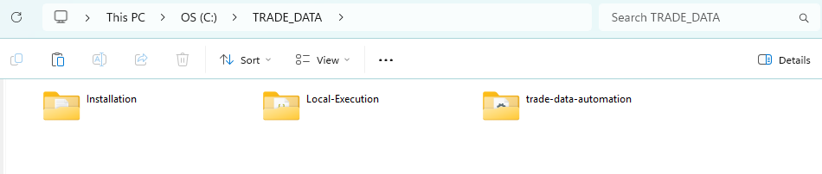
1) Installation : Contains all the installation files and instructions. Including the command prompt codes (if needed for troubleshooting as well).
2) Local-Execution : Specifically used for handling local run-time files, Databases, Raw Data etc. (Note: ‘RAW_DATA’ folder is inside this folder)
3) trade-data-automation : A folder cloned from GitHub repository ‘trade-data-automation’ containing all workflows, codes and config files made for this project. It is used to connect to GitHub for standard way of backing up and documenting projects. You can connect to and manage this project using GitHub.
Download and unzip the master TRADE_DATA.zip shared to you directly into your C:\ root drive.
Inside you should see two folders: Installation and Local-Execution.
The ‘trade-data-automation’ is not included since you should clone the repository for the latest changes. For instructions, refer to this section- > 4.2 GitHub Setup
Once you set up all these folders, the master folder is fully set up and now left with configurations. Refer to 4.1 Configuration Parameters

3.4.2 Nodejs installation
Nodejs is the run-time engine for hosting n8n locally. Without nodejs n8n will not run.
Node.js Version: v24.15.0 (LTS)(April152026)
Find the .msi file inside the Project folder under Installation>nodejs folder.
Open the file, which installs nodejs long term support version 24.15.0 on the computer.
File is located on C:\Program Files\nodejs\node.exe
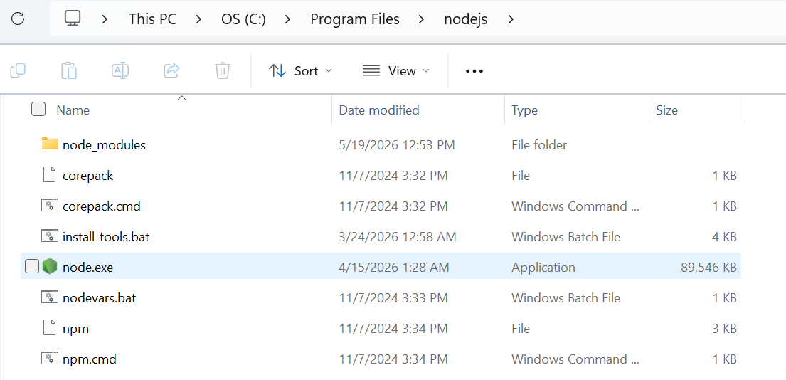
Verify installation by checking in cmd with node -v. If it returns something like v.24.15.0 its installed successfully.
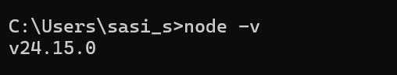

3.4.3 n8n Installation
Only execute this after successful installation of nodejs. There are two methods to setup n8n: Local installation(preferred) & npx method (not for long term stability).
i) Local installation:
Run the command below in cmd. This installs n8nv.2.20.11 locally under the user directory. And it takes around 35 mins to complete.
npm install -g n8n@2.20.11 --registry=https://registry.yarnpkg.com
After success it would show something like this:
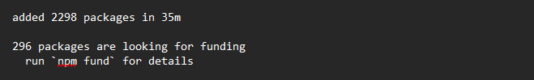
Execute the bat file or run ‘n8n’ in cmd to open n8n.
ii) npx method: (pulls n8n from server temporarily)
Run these commands in cmd.
npx --registry=https://registry.yarnpkg.com n8n@2.20.11
This will take around 5-10 mins. If successful it would show:
Editor is now accessible via: http://localhost:5678, press ‘o’ to open in the browser.

Next, we need to install Community nodes.
This is to install community nodes required for this project.
Community Nodes:
n8n-nodes-sqlite https://www.npmjs.com/package/n8n-nodes-sqlite
n8n-nodes-splitinbatches-advanced https://www.npmjs.com/package/n8n-nodes-splitinbatches-advanced
Open ‘community_nodes.txt’ file inside the Project folder. Copy the code and paste on to Command Prompt. OR you can use the code below also.
----------------------------------------------------------------------------------------------------------------------
npm config set registry https://registry.yarnpkg.com
if not exist "%USERPROFILE%\.n8n\nodes"
mkdir "%USERPROFILE%\.n8n\nodes"
cd %USERPROFILE%\.n8n\nodes
npm i n8n-nodes-sqlite
npm i n8n-nodes-splitinbatches-advanced
----------------------------------------------------------------------------------------------------------------------
After success, it will show like this:
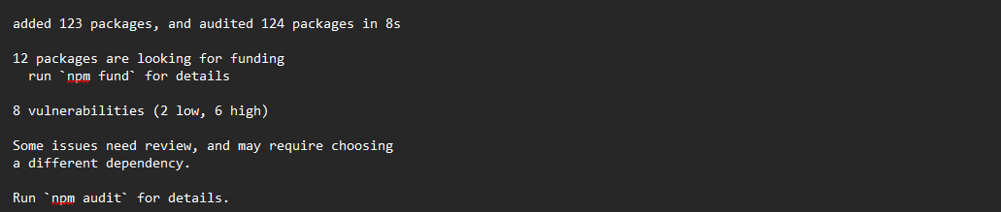
Re-launch n8n for applying these nodes.

3.4.4 KNIME Analytics Platform
KNIME is an open-sourced platform mainly used for data cleaning, data analysis and machine learning. It is known for its simple drag and drop node-based interface and its ability to manage complex bulky data.
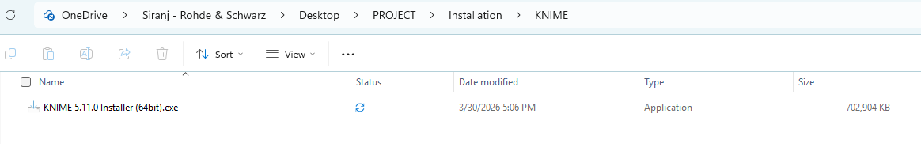
Since it’s open-sourced software, the installation is easy. You can install KNIME using the .exe installation file under the installation>KNIME folder.
Just open the file and follow the procedures.
Alternatively, you can download it manually from the official site. https://www.knime.com/downloads
Once you are in the selection of workspace,
Select the workspace to this location: C:\TRADE_DATA\trade-data-automation\workflows\knime
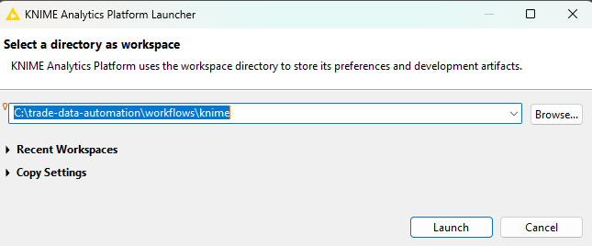
If the selection of workspace is correct, once you open KNIME you should see two workflows: Initial_Process and Final_Process.

Next, we need to install NodePit Batch Extension.
You can refer to this source also. https://nodepit.com/product/nodepit/installation
Download URL mentioned below: https://download.nodepit.com/5.11
For executing knime workflow, the knime batch executor is not available in fact discontinued in this year. Alternative is nodepit batch extension for knime.
Install the Free "NodePit Batch" Extension
- Open your KNIME Desktop application.
- Go to File ➔ Preferences ➔ Install/Update ➔ Available Software Sites.
- Click Add... and paste this exact URL (assuming you are on version 5.11): https://download.nodepit.com/5.11
- Click Apply and Close.
- Now, go to File ➔ Install KNIME Extensions...
- In the dropdown at the top, select the NodePit site you just added.
- Search for NodePit Batch and NodePit Runner for KNIME, check the box, install it, and restart KNIME
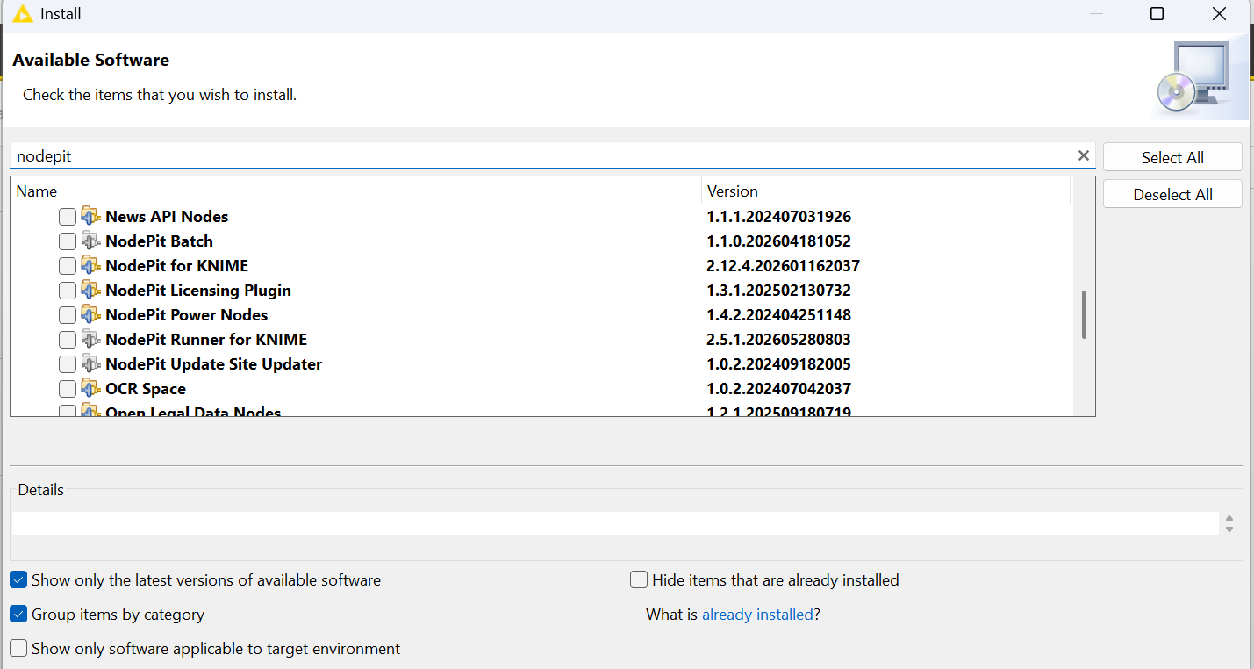

3.4.5 DB Browser (SQLite)
This is a tool to manage the SQLite database files (Trade_Data.db and model_database.db). You can edit, insert and remove any rows from these databases manually if needed.
To install this tool, just find and open the .msi folder under Installation>DB Browser (SQLite) folder.
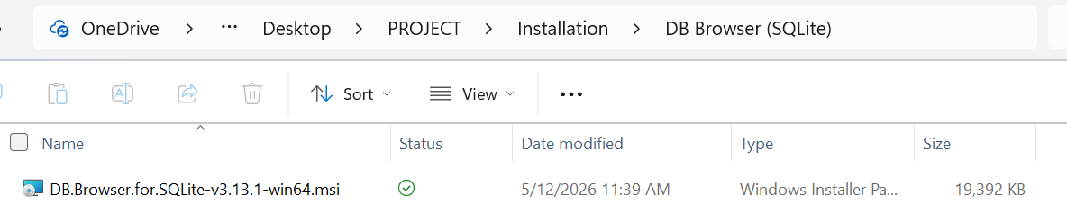

3.4.6 Power BI Desktop
Power BI Desktop is a business analytics and data visualization platform. We use this software to develop a dashboard to gain insights from out trade data. In later stages of this project, we may need a pro version for further features.
Just download software directly from the Microsoft Store. And open the dashboard under workflows>Power BI>[dashboard_name].pbix
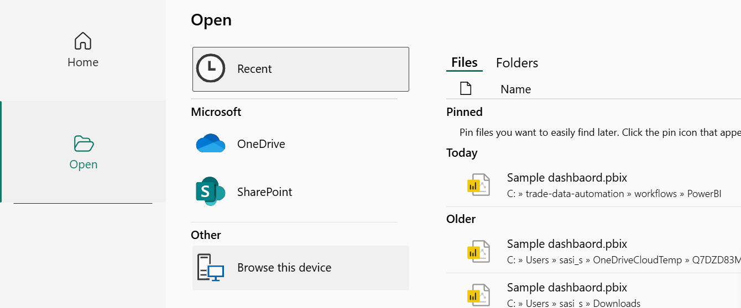
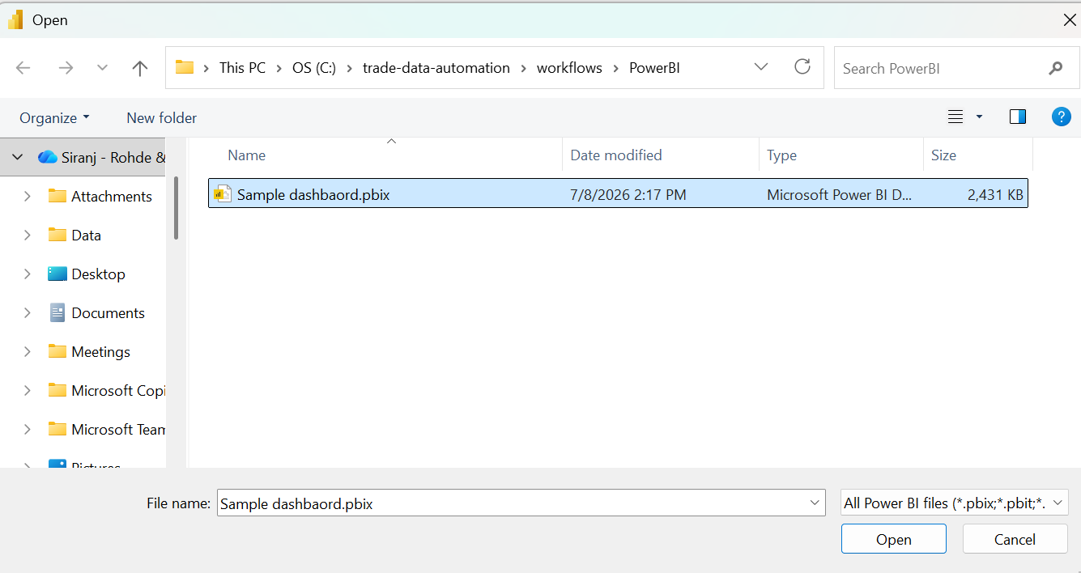

3.4.7 Git GUI
Git GUI allows us to connect with GitHub cloud for managing projects using command line. Install by executing the file available inside github folder. For the Destination Location and all other settings just proceed with the default settings. No need to change anything.
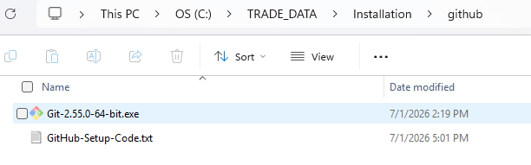
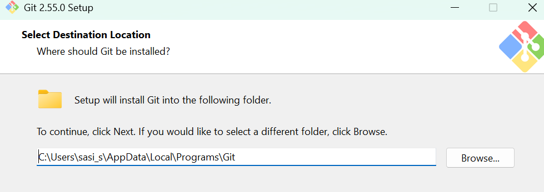
You can check the installation using command prompt.
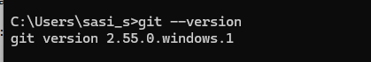

4. Configuration Guide

4.1 Configuration Parameters
[Explain key configuration files (e.g., .env, JSON, YAML), environment variables, and customizable parameters.]
Start typing your content here...

4.1.1 Adding workflows to n8n
For adding workflows, create a workflow then import the respective workflows from the folder workflows>n8n which is in JSON format. Just import and rename the workflow (if needed) and save it.
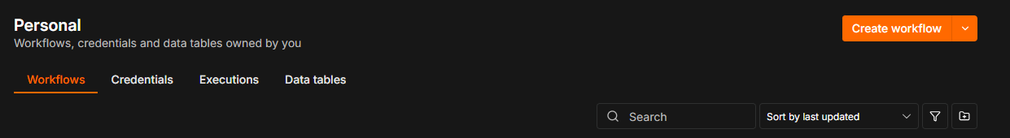
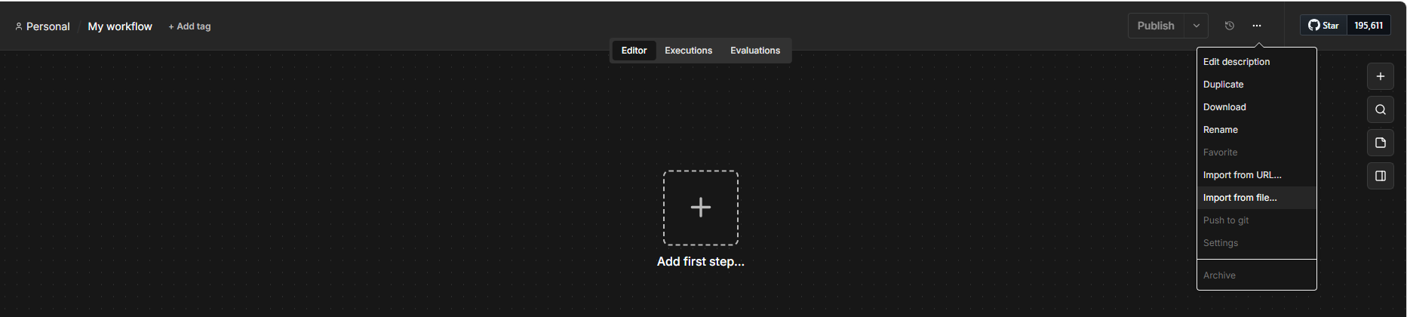
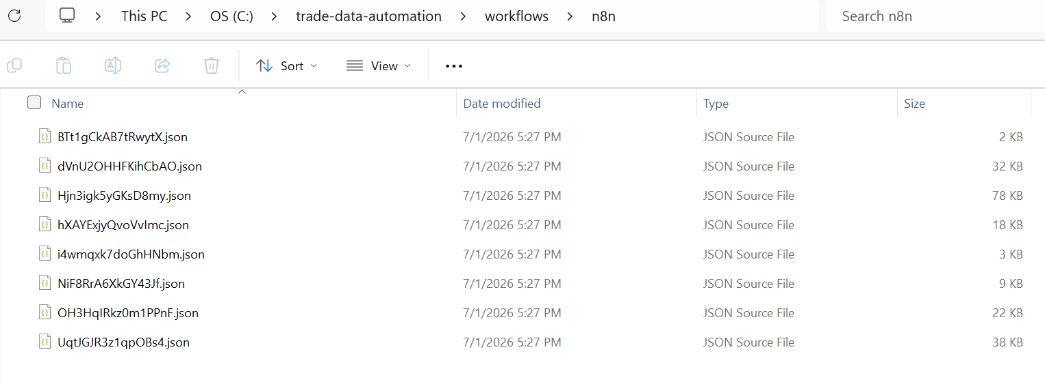
Import all the files from the folder. Total of 4 workflows. Remember to publish the workflow.

4.1.2 Configuring API Key for n8n
Once you have the API Key and Credits ready, you can connect your API key with n8n for using the model.
Go to the ‘AI_Process’ workflow, click on OpenAI Chat Model (or another one if you want to change model).
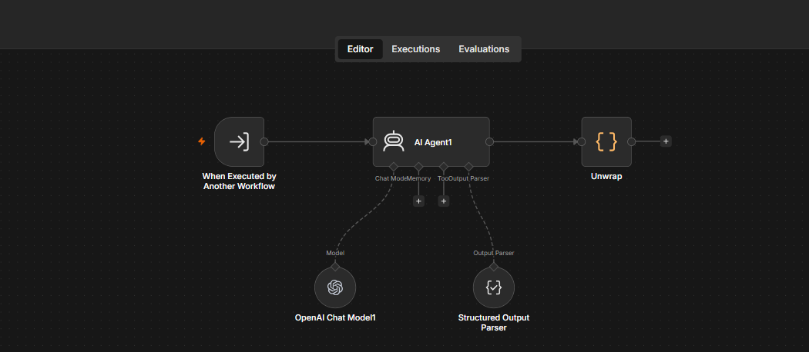
In this section, create a new Credential by pasting your new key (or existing one) and save it. (which you only need to do one time). 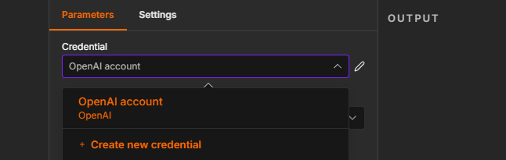
Once saved, the connection testing should be turned green, indicating successful connection.
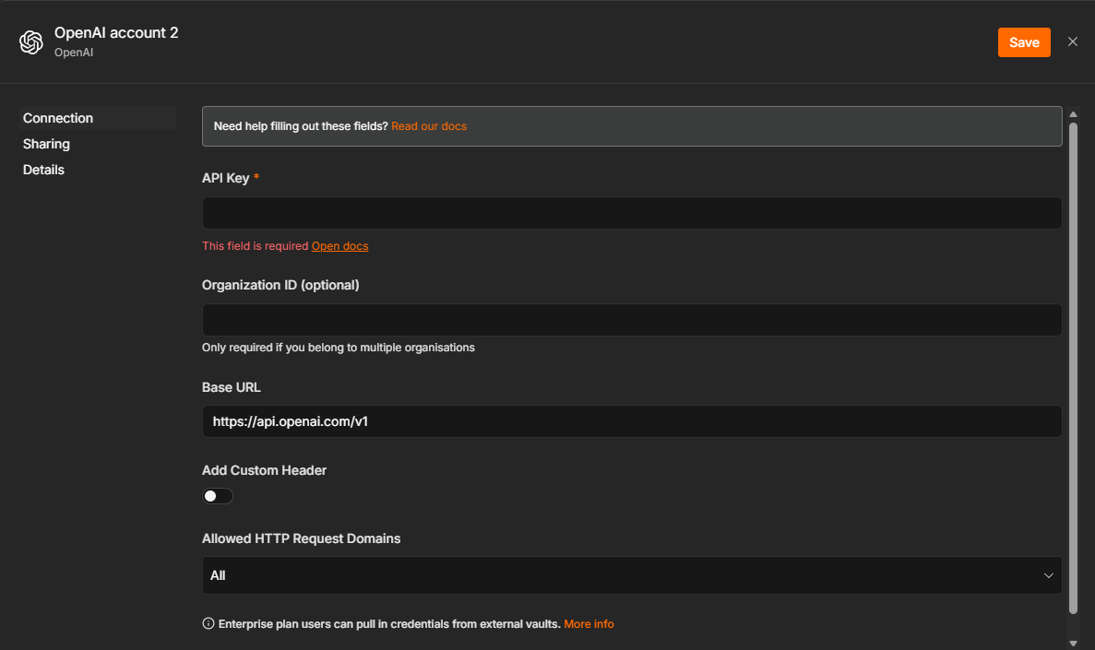

4.1.3 Configuring API Key for KNIME (.env file)
Once you have the API Key, just paste the key along with the URL (which the default value in the file is OpenRouter URL assuming the usage of OpenRouter, if not use the URL of the platform in which the model is used) in the .env file located under trade-data-automation folder.
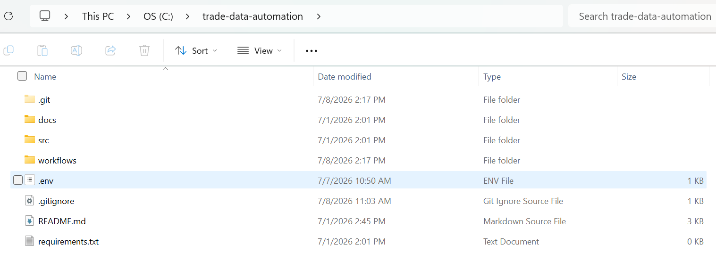
Since it’s a .env file, this particular file is ignored by GitHub (gitignore) to protect API Key from accidentally uploading to internet.

4.2 GitHub Setup
Before setting up make sure to install the Git GUI so that we can connect with GitHub using command line. To Install Git GUI, refer here-> 3.4.7 Git GUI
For the initial phase pulling files only is good enough to run the project. But along the way it is best advised to clone and update the repository with latest changes made (if any) since documenting the progress of this project is equally important.
Getting the files from the repository (cloning the repo) doesn’t require you to have a GitHub account. But if you wish to push changes to the GitHub cloud during later stages of this project you should have a GitHub account and should fork (make a copy to your account) the existing repository mentioned.
Both instructions are below.

4.2.1 Pulling files only.
The whole repository should be cloned to the ‘TRADE_DATA’ folder directly. To do that we can use the native git command in command prompt.
Copy the code available inside the installation>github folder> Git_CloneRepo_FILES_ONLY.txt
Just paste directly into command prompt. After success it would show like this.
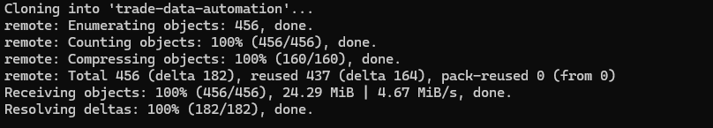
Now the repo is successfully cloned into your local system.
Inside the folder, there will be all the necessary workflows and files.
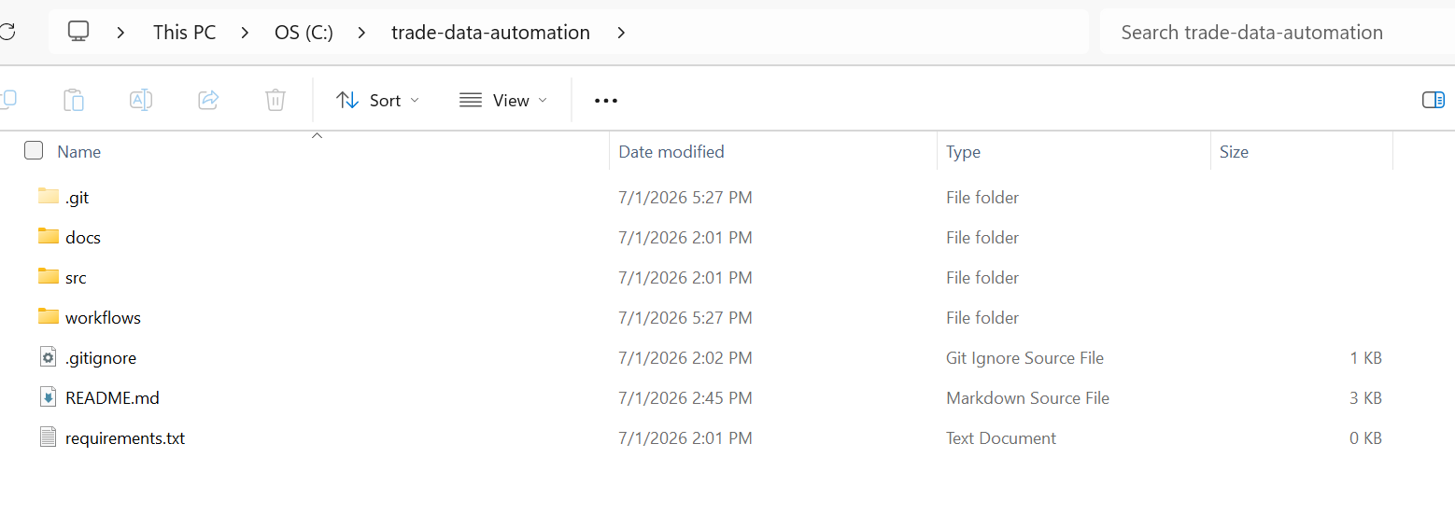

4.2.2 Connecting GitHub account
To set up this connection, you need to have a GitHub account, Sign up here. GitHub
If you already have, go to the project repository, click fork. 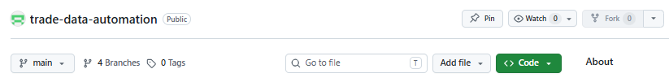
After forking, you should see the copy of this repository in your GitHub account.
Next, Find the code available at installation>github folder>GitHub_ForkRepo_ConnectNewUser.txt
Note: There are two sets of codes inside because the code will be slightly different if you already have the folder cloned.
Insert your username and github account email to the fields to match your new account. Change the clone repository path/origin to your new path (change the username only).
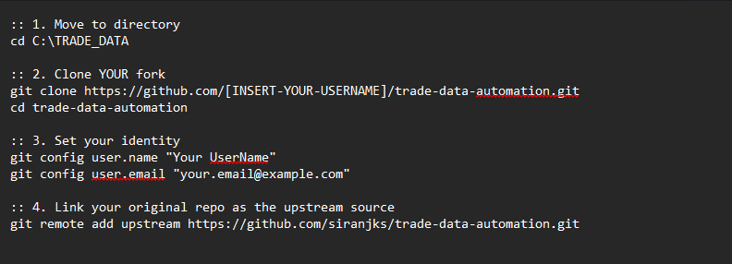
Next, copy and run the code (whichever applicable) into your command prompt. This will clone and connect your new repository. Now you can push changes to your new repository if needed.
For using GitHub through command line, you may refer to Git-CommandLine-Cheatsheet

4.3 Environment Setup
[Detail the differences and setup procedures for Local Development, Staging, and Production environments.]
Start typing your content here...

4.3 External Services Integration
[Describe how to authenticate and connect to third-party APIs, databases, message queues, or external services.]
In this project, we are using OpenRouter to connect with AI model OpenAI gpt-4o for classification. We could use another model too, but considering the cost and accuracy gpt-4o is overall better.
The advantage of using OpenRouter is that it’s a service that lets you access hundreds of different AI models (like Gemini, Claude, and GPT) using just one API key.
Create or use existing account to sign in to https://openrouter.ai/workspaces/
Then create a new API key by clicking new key.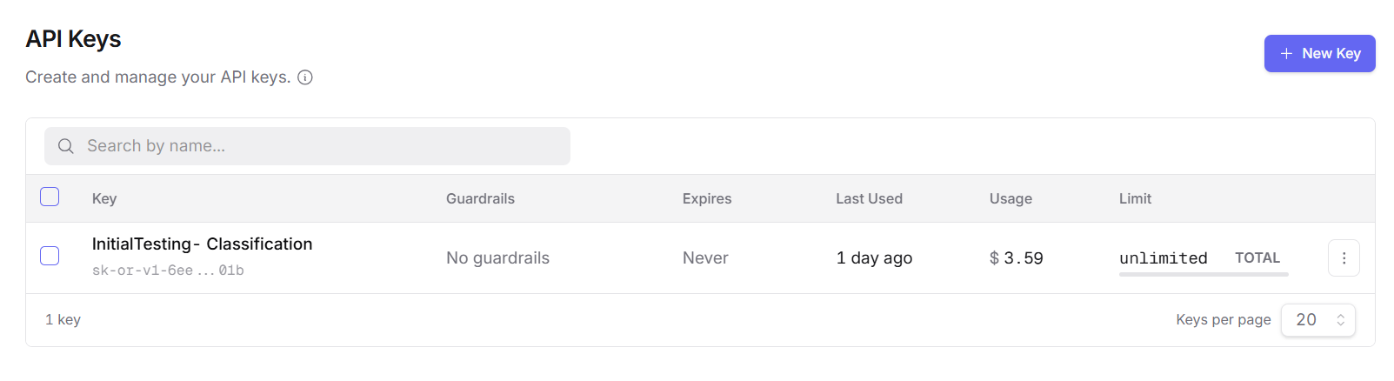
After API key creation, copy the key into the .env file under the folder trade-data-automation. This key is also used inside n8n to configure chat model. Refer to this Configuration section for configuring for both n8n and knime. 4.1 Configuration Parameters
For using this model, we need credits. You can add credits under Credits section under Accounts.
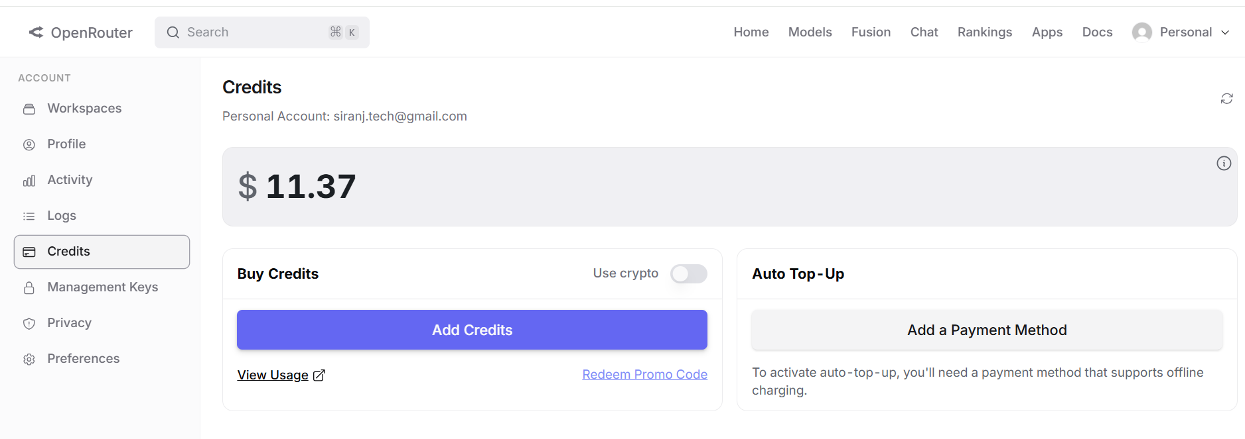

5. Usage Guide

5.1 User Interface Overview
[Describe the main components of the UI, navigation structure, and general layout.]
Main components/front-end UI in this project include TRADE_DATA & RAW_INPUT folder, .bat files for executing the whole project/launching n8n only, Power BI for viewing the dashboard, and DB Browser (SQLite) for viewing & managing database. 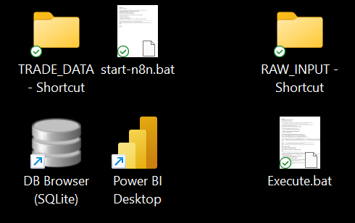
The shortcuts and these files will be inside the installation> shortcuts&.bat. If not, you can create shortcuts manually also.

5.2 User Authentication
[Explain the login process, session management, password resets, and multi-factor authentication if applicable.]
Self-hosting n8n allows you to create an account in the localhost. You can use your email and password to sign in.
For the API keys also, you need to have an account. It could be your personal account, or you could use the company account. Refer to 4.3 External Services Integration
For using GitHub, you’ll need an account as well.
Apart from this there is no other authentication needed as the project-related files are directly saved into C drive.

5.3 Core Functionality
[Provide step-by-step instructions for the primary workflows and features of the application.]
In this section, we discuss the functionality of the system. Main objective is to build an automation for the trade data which is then visualized in Power BI.
Step 1: Export the raw data from tendata.
Step 2: Copy or directly put the file inside the folder ‘RAW_INPUT’ 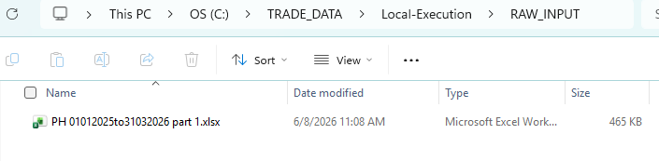
Step 3: Execute the Windows Batch file ‘Execute.bat’
Step 4: Wait for the program to finish & for the success message. 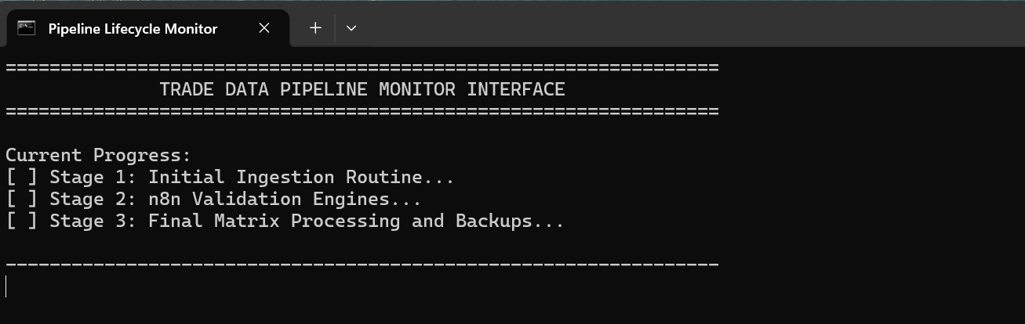
Step 5: Open Power BI Dashboard and refresh the data.
Result: Now the data is cleaned, processed, classified, saved into the database and updated in the dashboard by just one execution.

The start of this entire workflow is in the raw data itself. The raw data is exported from the tendata platform is then copied to the RAW_INPUT folder.
And once the user intended data is successfully copied to the folder, we can execute the ‘Execute.bat’ file which executes the first workflow in this project, KNIME ‘Initial_Process’. Meanwhile, the user is displayed with status of process completion.
RAW_INPUT>Execute.bat>Initial_Process>Phase1_Main(inside 3 workflows are used)>Final_Process>trade_data.db>Power BI Dashboard

5.4 Advanced Features
[Detail administrative capabilities, reporting tools, or less commonly used features.]
You could view the database yourself by using the ‘DB Browser (SQLite) software. 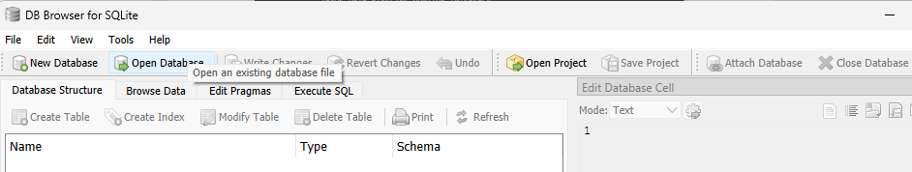
Open and click ‘Open Database’ and navigate to our database files stored in the Local_Execution folder.
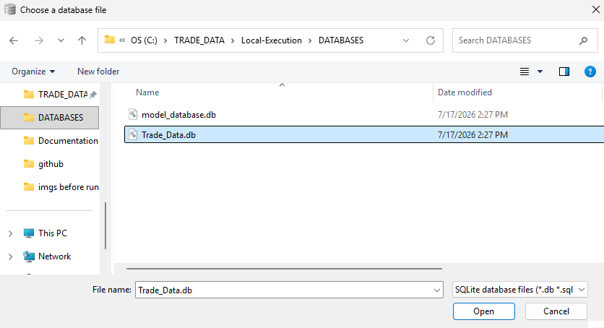
Click ‘Browse data’ to view data inside that database.
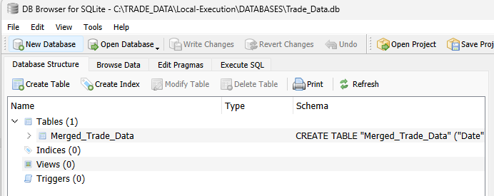
The data will be shown like this:
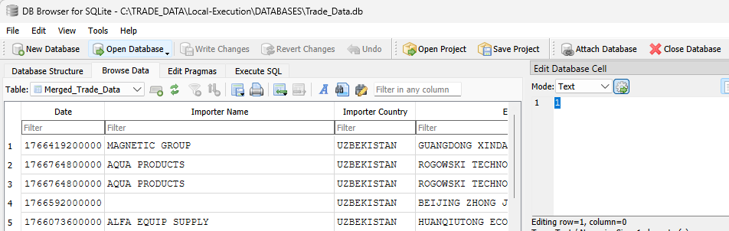
You could make any changes, add new data then click ‘Write changes’ if any changes are made so that it is properly saved into database. If there are no changes, make sure to click ‘Close database’ to disconnect from database.
In case of the model database, since it contains 4 tables, you need to select the table when you need to view them. Like this:
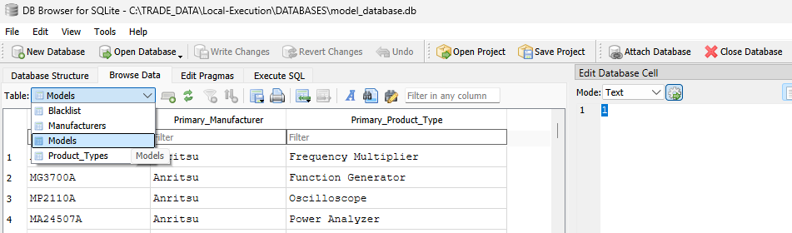
Select ‘Models’ table as we only use that currently.

5.5 Troubleshooting
[List common user-facing errors, their potential causes, and how to resolve them.]

5.5.1 Using log files (Recommended)
The first step in troubleshooting is to look at the log files. The files are in TRADE_DATA>Local-Execution>logs
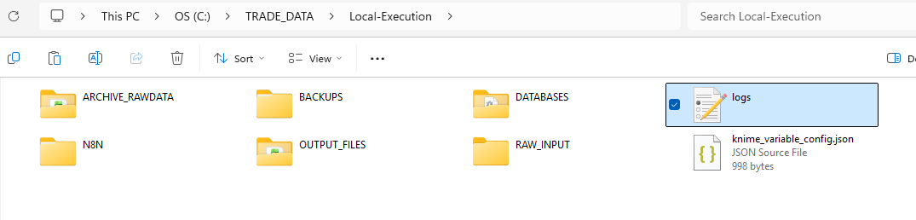
Inside you will see two log files named initial_process.log and final_process.log.
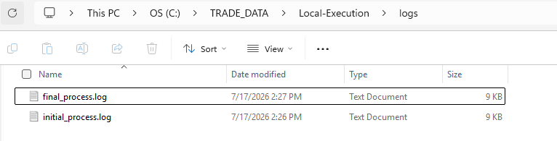
Initial process log is for viewing the batch file errors or KNIME Initial_Process workflow errors.
Detailed explanation: explained clearly, the entire command prompt terminal responses from running the Execute.bat file and subsequent triggering of KNIME initial process workflow will be recorded into this log file (records until the initial process workflow is successful in triggering the n8n workflow).
Final process log is for viewing the errors related to NodePit batch executor and the KNIME Final_Process workflow errors.
Detailed explanation: The last node of n8n process is an execute node which executes code directly into command prompt, so the purpose of the code is to execute KNIME workflow named ‘Final_Process’. So, if any error occurs in executing the code itself or in the execution of the Final Process workflow, it will be recorded.
So, in any case of any potential error in either of these areas, I strongly recommend you investigate the respective log files to find the exact cause of this error so that you can rectify it.
If you are not sure of spotting the error, you may use the help of AI to find it if needed. Just copy the entire log and prompt the AI.

5.5.2 Using n8n execution log
If you specifically want to look at errors inside the n8n workflows, you can see execution tab at n8n dashboard.
Execute ‘start-n8n.bat’ file and press ‘o’ to open up n8n. Alternatively go to localhost:5678.
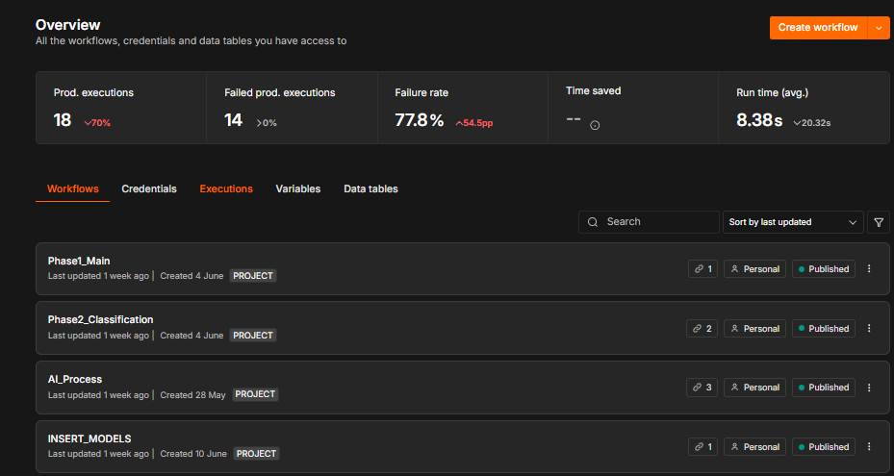
You can go to the execution tab to see all the successful or error executions. If you go into it, you can see which node is having the error.
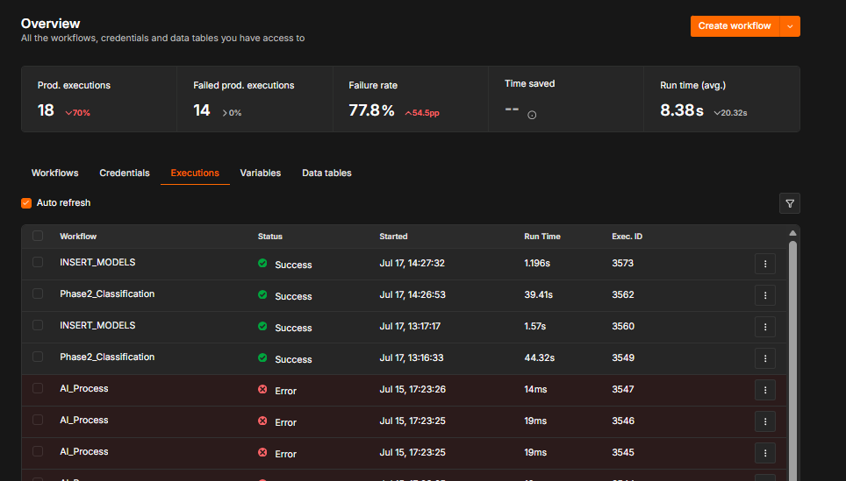
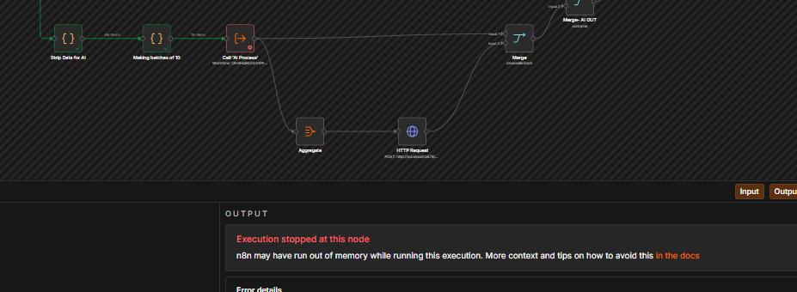
WSL issue
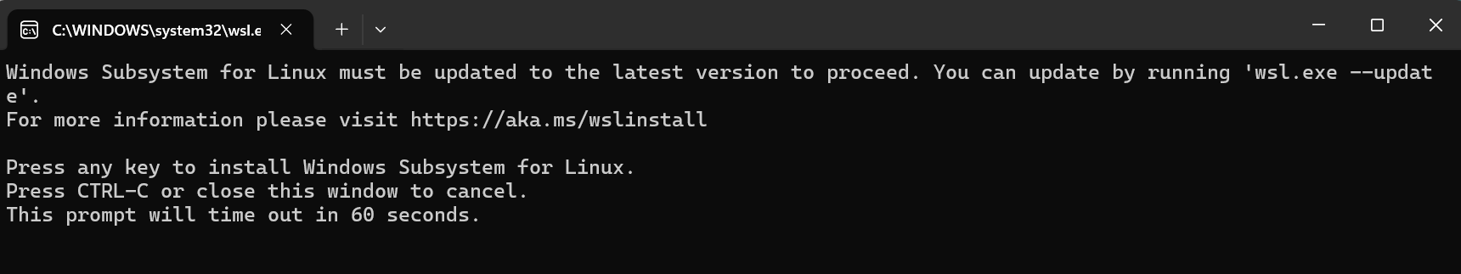
If you happen to get a window like this, then please ignore the entire window by pressing ctrl+c, as installing WSL alone doesn’t interfere with our project, but it may lead to some problem in the later stages. So, it’s best advised to just ignore or close that prompt window.

6. API Documentation

6.1 Endpoints
In this project, we only use ‘POST’ method from all the HTTP methods as we only need to use it for triggering the n8n workflow from KNIME.
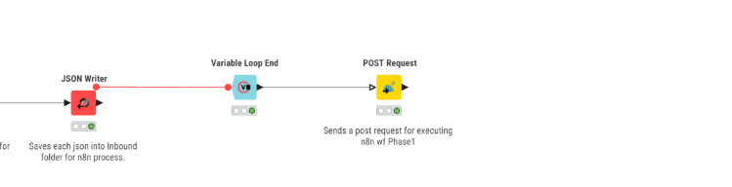
This specific ‘POST Request’ node triggers the Phase1_Main n8n workflow.

6.2 Request and Response Formats
The most important data format in this project would be JSON format. The reason why it’s the important format is that it is used in:
- Config and log files
- Trade data transferred between n8n and KNIME. (split into batches of JSON files)
- Inside workflows: between nodes
- AI Output formatting
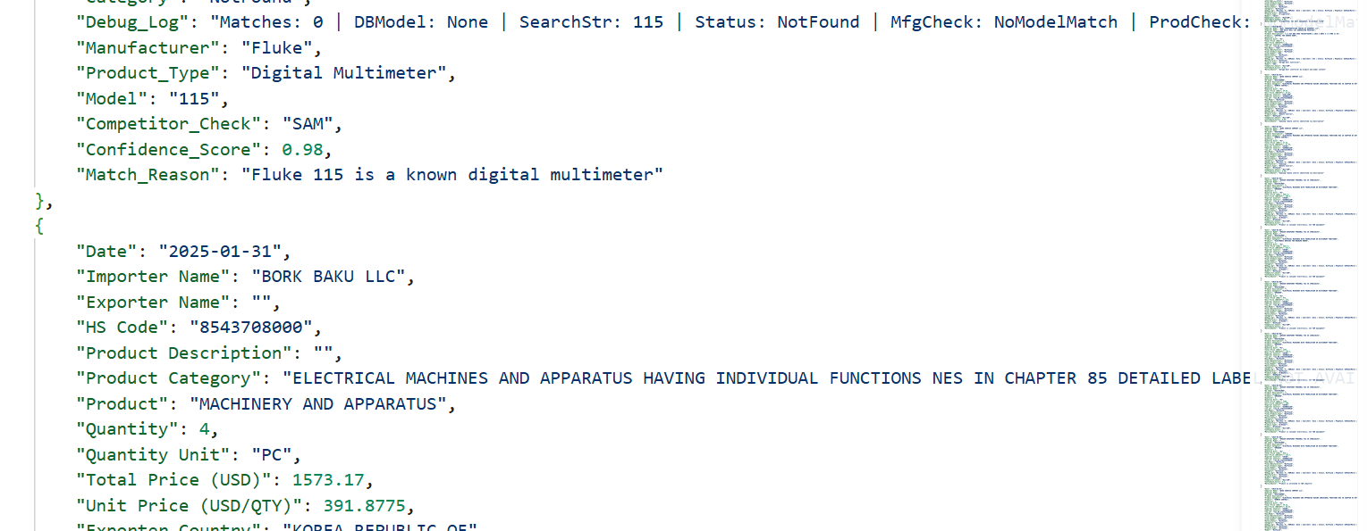

7. Database Schema

7.1 Entity-Relationship Diagram
[Insert or link to the ERD (Entity-Relationship Diagram) of the database architecture.]
Start typing your content here...

7.2 Table Definitions
[Describe key tables, primary keys, and significant columns. Explain the purpose of core tables.]
Two databases: model_database.db (4 tables) and Trade_Data.db.(1 table)
Created an unique index for the model_database.db.
CREATE UNIQUE INDEX "idx_3_pillar_identity" ON "Models" (
"Model_Number",
"Primary_Manufacturer",
"Primary_Product_Type"
);

7.3 Relationships and Constraints
[Explain foreign keys, one-to-many/many-to-many relationships, unique constraints, and data integrity rules.]
Start typing your content here...

8. Testing

8.1 Test Plan
You can find the testing files under testing folder. Throughout the project, the testing has been done in various phases. For example, some testing is done only to test the n8n workflows or KNIME workflows while others would be to test certain logical data flow. The main purpose of this testing is that it helps us to get deeper understanding of the things used from the developer perspective.
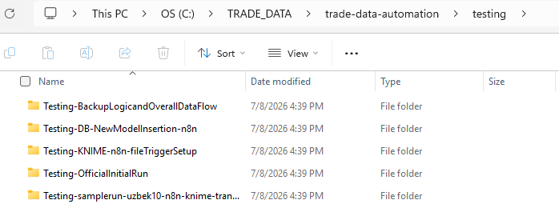
You can find all the screenshots and related files inside the test folders.

8.2 Test Cases
[Link to test management tools or list the essential test cases required to validate core functionality.]
Start typing your content here...
Here we will discuss the final testing of this data pipeline.
Environment setup
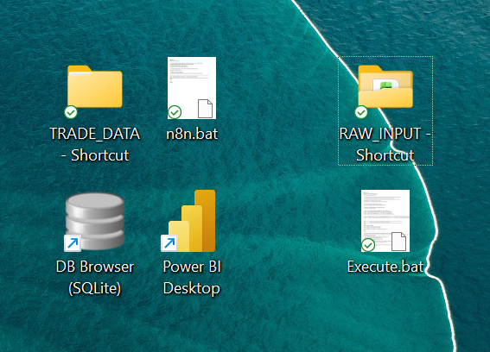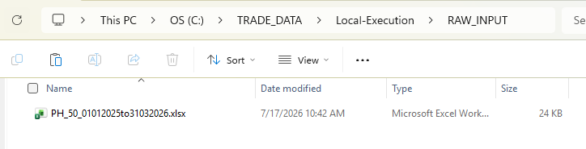
Put the raw data inside the folder. If we look at the database now it would be like:
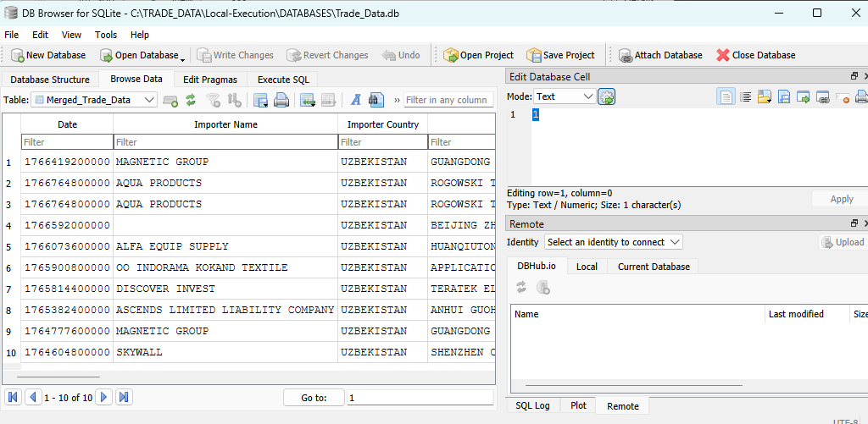
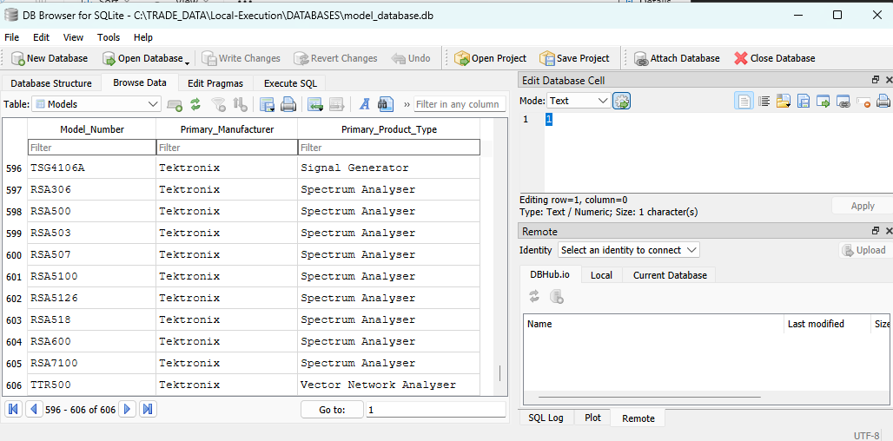
After execution, there will be a progress showing window which is like:
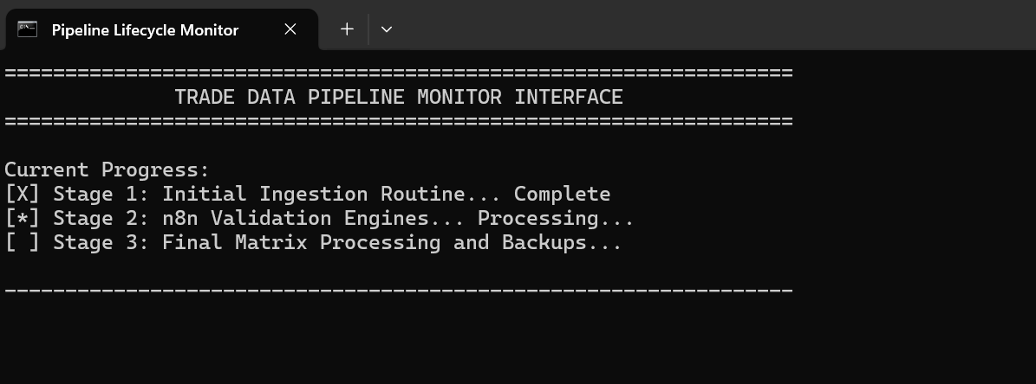
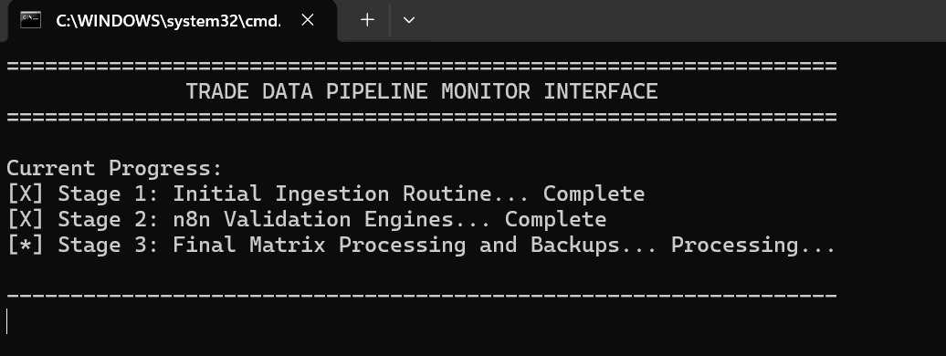

8.3 Test Results
The resulting new data is entered and changes are made:
Model database now has 606 rows; Trade database has 10 rows.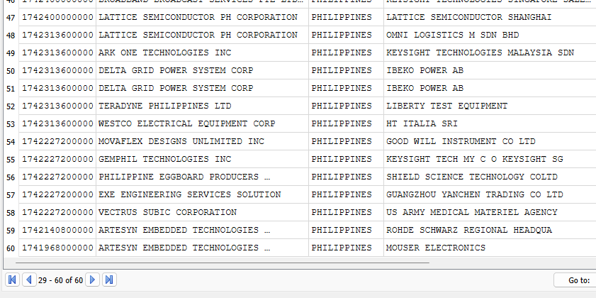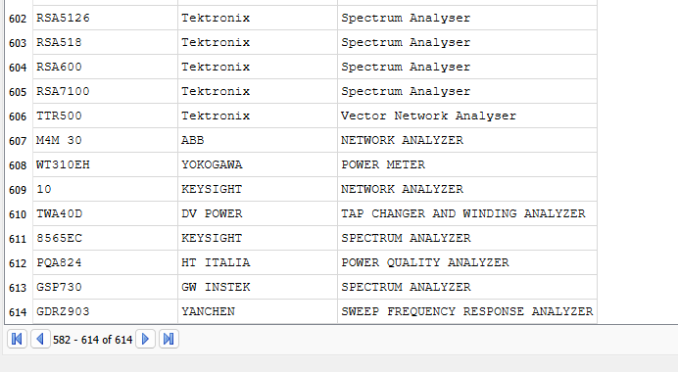
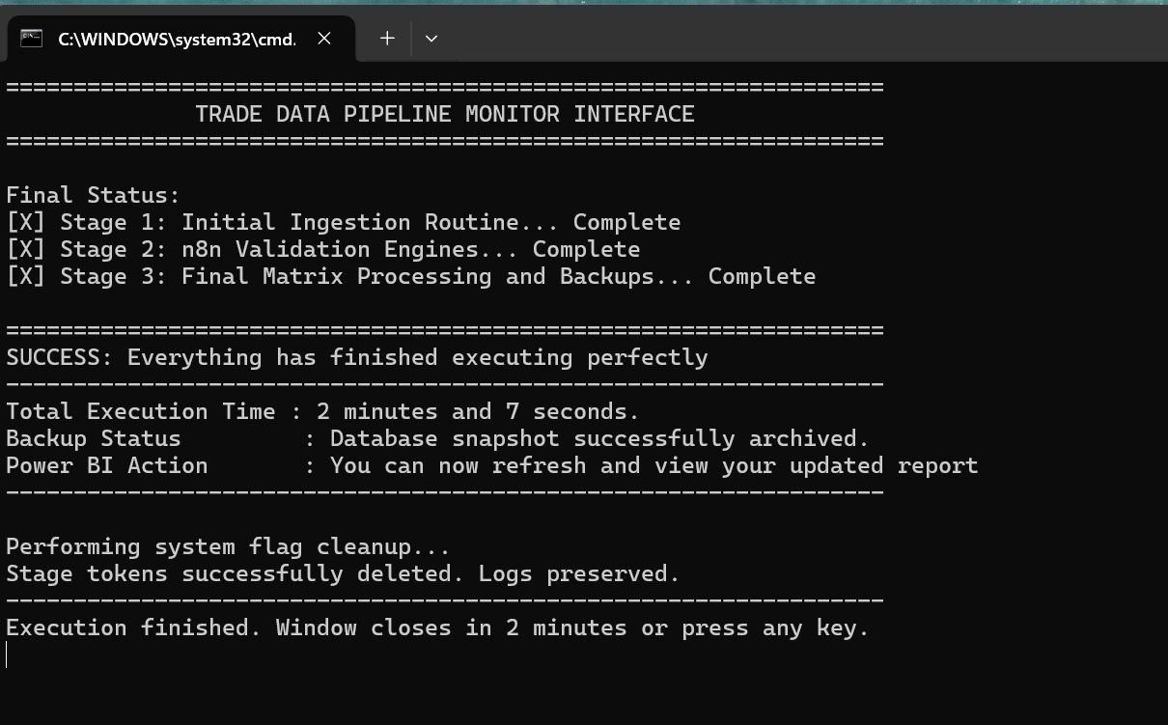

9. Support and Maintenance

9.1 Troubleshooting Guide
These include the different errors encountered during installation and configuration, hopefully if you ever encounter an error, you’d find a similar one here so you’d know the solution
Error #1: Regional Restrictions on API
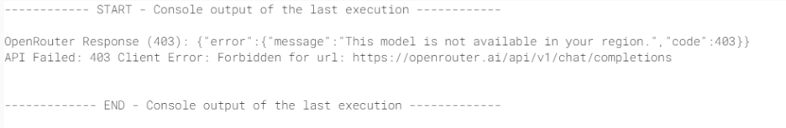
The error message just showed the error number 2nd error line before. I changed part of the script to show the response of OpenRouter’s API (Routing issues). Error message is caused by assigned Region Zscaler VPN service.
Change #1
Originally, the AI model set in this script was Claude Anthropic Haiku 3 (?). However, that model is restricted in my VPN Region (HongKong), along with OpenAI models and Gemini models. The one I chose right now is Qwen/qwen-2.5-72b-instruct because it is best for varying shipping datasets (which is what the datasets are). IDEALLY, if it isn’t restricted in your region, use the OpenAI model. It is cheaper and best used in development. Qwen2.5 Coder Instruct 32B vs GPT-4o mini: Model Comparison | Artificial Analysis
BUT, if management wants a more accurate AI model, I suggest using Claude’s higher models for reasoning.

Error #2: Read Config File Path
Okay so, after the initial process workflow in Knime, you’re expecting it to trigger the webhook on n8n. My initial problem was I couldn’t see it executing. You just have set the save successful production executions to “save.” It’s on the three dots and settings. Now to the actual issue. See, it will stop at the Read Config File Node because the file path is set to C:\local\n8n… something. I just changed it to this file path for me "C:\TRADE_DATA\Local-Execution\knime_variable_config.json" However, if yours is different then just change it

Error #3: Batch File Not Showing Progress
The batch file wasn’t updating as it should as shown in its code. I change the n8n execute command in Phase 1 to make it produce the appropriate text file. I did the same in Initial Process workflow in KNIME using the Java Edit Variable. It should output the “stage 2” and “stage 3” .txt files
Error #4: N8N and RAW_INPUT folder getting deleted
This was an issue within KNIME – Final Process. A box was ticked indicating to delete the source folders within the variable. I have temporarily unchecked them. I might change this to instead reestablish those folders after deleting them.
Error #5: Nodes Exclude
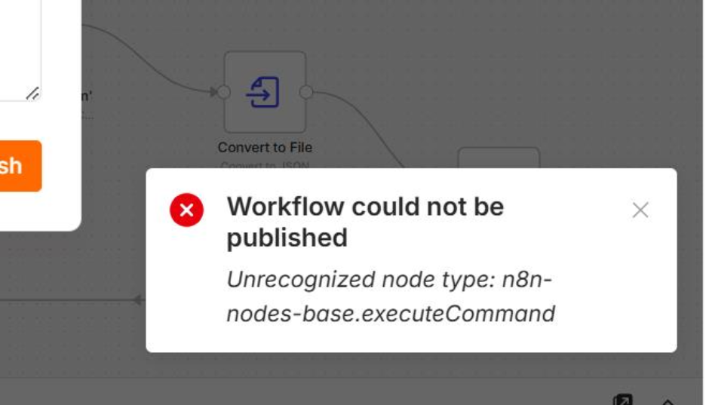
Add Variable Name: NODES_EXCLUDE Value: [] under system variables.

Error #6: Access to file not allowed
After changing the Read Config File path, an error such as “Access to the file is not allowed. Allowed paths: C:\Users.n8n-file” or “Access to the file is not allowed. Allowed paths: C:\TRADE_DATA\trade-data-automation” may appear. To resolve this issue, open Edit System Variables and add a new system environment variable named N8N_RESTRICT_FILE_ACCESS_TO. Set the variable value to C:\Users.n8n-files; C:\TRADE_DATA\Local-Execution; C:\TRADE_DATA\trade-data-automation.

9.2 Frequently Asked Questions (FAQs)
[List and answer the most common questions raised by developers or users.]
Start typing your content here...

9.3 Known Issues and Limitations

9.4 Contact Information
[Provide the names, roles, and email addresses of the system owners, support team, or primary maintainers.]
Primary Developer: siranjks2580@gmail.com [The intern preceding me]
Secondary Developer: daphnieabano@gmail.com [me]

10. Future Aspects
In this section, we will discuss the future progress or expectations of this project. The things shared in this section are based on both the technical aspects and supervisor’s needs.
Thus, the suggested changes according to priority include the following:
- AI Agent Prompt fine tuning
The workflow for using a text file as a prompt was already implemented but can’t fine tune this to the AI since the developer at the time was limited to Qwen only.
- Dashboard development
- Research Cache
Reuse recent company research instead of researching the same importer during every run.
- Central Configuration File
Store folder paths, report settings, thresholds, and processing options in one location. QoL (Quality of Life) feature so that future interns don’t have to change the path every installation and configuration.
- Single User Interface
Start runs, choose options, monitor status, and open outputs from one control panel.
- Search string fine tuning in tendata/tradedata pro
- Cloud Implementation

11. Change Log

11.1 Version History
[Track document versions, dates, authors, and reviewers.]
Version | Date | Author | Description of Changes
1.0 | 2026-08-14 | Siranj | Initial Draft
1.1 | 2026-11-09 | Daphnie | Added Changes
1.0 | YYYY-MM-DD | Name | Initial Draft

11.2 Change Summary
The changes I made within the document are highlighted. This only includes Daphnie’s changes, I will leave it up to Jia Yuan to add hers c:
Change #1
Originally, the AI model set in this script was Claude Anthropic Haiku 3 (?). However, that model is restricted in my VPN Region (HongKong), along with OpenAI models and Gemini models. The one I chose right now is Qwen/qwen-2.5-72b-instruct because it is best for varying shipping datasets (which is what the datasets are). IDEALLY, if it isn’t restricted in your region, use the OpenAI model. It is cheaper and best used in development. Qwen2.5 Coder Instruct 32B vs GPT-4o mini: Model Comparison | Artificial Analysis
Change #2: Changing the KNIME workflow to get rid of duplicates in the output file + More changes
I found an issue within the KNIME workflow. Whenever I try to run the same document, it appends the existing master file, creating duplicate rows. I just changed the workflow to compare the data within the run and the old master file and then get rid of the duplicates (I added another branch for the workflow for this function). I also made the original branch make unique files for each run of the program, so it’s better for tracking in the future.
Change #3: More Changes in the KNIME workflow and new N8N workflow
I added an AI analysis writer.I used a python script and then a post request node that would send the request to the N8N workflow that I made (Current_Run_Market_Analysis). This just makes an analysis for the data in the current run, so basically everything that’s not in the master file yet. I could modify it so it can make both (but it depends on the program requirements). ALSO THIS IS IMPORTANT!! Change the AI model used here. I got no other choice but to use Qwen. The output heavily relies on the AI used, and if you have another (better) search tool for the ai agent node, you can experiment and replace it with that.
Change #5: More Changes in the KNIME workflow and new N8N workflow
Added error handler for N8N, should be a .txt file here 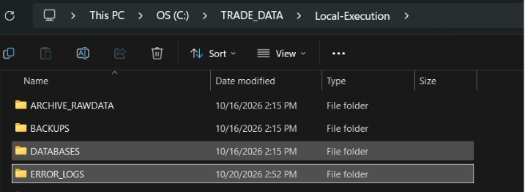

12. Glossary

12.1 References

For nodes related: https://docs.n8n.io/integrations

